[Title] No More Than 17 Words and Use "Title Case"… [size 13]
Andres P. Marcos^{1*}, Daniel Gapas² [size 12]

¹ Name of affiliation of first author, Country [Size 11]
² Name of affiliation of second author, Country
*Corresponding author's email:
*ORCID:

® Copyright (c) 2025 authors

Received: ..../...../2025 Revision: ..../...../2025 Accepted: ..../...../2025 Online: ..../...../2025

[Title] No More Than 17 Words and Use "Title Case"… [size 13]

ABSTRACT
This is a concise summary of the important points of the paper, not to exceed 250 words. The abstract should be placed on a page after the title page. The title of the paper should be indicated above the abstract. Keywords and phrases should not be more than five and should be arranged alphabetically to be written just after the abstract. [Times New Roman 11 points]

Keywords: [from 3 – 5 keywords alphabetically arranged]

Introduction [Heading 1][size 13]
The introduction includes a brief background of the study, a short survey of relevant literature, research gap, statement of the problem, the research objectives, significance of the study and the scope and delimitation. This should be in Times New Roman, 12 points written without subheadings of its different components.
Here are some rules to remember for in-text citations. For direct quotes of fewer than 40 words, use the author-date citation system, include a page number (p. or pp.) or other locator, and incorporate the quote into the paragraph.
This is an example for citation in narrative form: According to the APA (2020), “a direct quotation reproduces words verbatim from another work” (p. 270).
This is an example for citation in parenthetical form: “A direct quotation reproduces words verbatim from another work” (APA, 2020, p. 270).
For block quotes (of 40 words or more): Do not use quotation marks. Start the quotation on a new line indented 0.5in from the left margin. Double space the block quotation. The parenthetical reference goes after the final period. Researchers have studied how people talk to themselves:
Inner speech is a paradoxical phenomenon. It is an experience that is central to many people’s everyday lives, and yet it presents considerable challenges to any effort to study it scientifically. Nevertheless, a wide range of methodologies and approaches have combined to shed light on the subjective experience of inner speech and its cognitive and neural underpinnings. (Alderson-Day & Fernyhough, 2015, p. 957)
This template intends to ease formatting task but always refer to the complete set of guidelines. We follow the APA style (7th ed).

Methods [Heading 1] [size 13]
Pedagogical Setting & Participants [Heading Level 2] [size 12]
The methodology includes the locale of the study, the research design, the variables of the study, including the theoretical/conceptual framework of the study, data gathering procedure, and statistical analysis.

Design of the Study [Heading Level 3] [size 12]
The methodology should define the overall approach employed in your study and explain alignment with the objectives. Discuss the justification of the choice of method, its strengths, limitations and mitigation

Data collection & analysis [Heading Level 3] [size 12]
The data collection methods should be described clearly. Specify the tools/instruments used and explain the sampling/participant selection process. Indicate the data analysis techniques employed (i.e. for quantitative- statistical method or software used; for qualitative – thematic/content analysis). Provide sufficient information for readers to understand how you arrive at your findings.
Summarize the key components of your methodology and emphasize their importance in shaping the credibility and rigor of your research.

Results [Heading 1][size 13]
Pedagogical Setting & Participants [Heading Level 2] [size 12]
The results and discussion could be presented together or separately depending on what best conveys the research outputs. Brevity and clarity of arguments must be observed so that the problems/objectives of the study are addressed.
Presenting the results under the lights of the research questions. [Heading Level 3] [size 12]
Include only data of primary importance. Use sub-headings to keep results of the same type together and present them clearly to easily understand. Make use of charts, figures, illustrations diagrams and tables to clearly present your findings.
Illustrations, figures, and tables should be placed immediately after they are cited (Table 1). They must be numbered using Arabic numerals and should include concise descriptive titles. Titles should be clear, and column headings should be brief, with units of measurement in parentheses. Only the first letter of the first word of titles and headings should be capitalized; the rest should be presented in lowercase unless they are proper nouns. The type size [11 points] of tables should not be reduced to accommodate data. Symbols and abbreviations should be defined below each table.

Table 1. Table titles should be clear, only the first letter of the first word is capitalized [11points]
 | Parameters | n* | M | S.D.
17 | I found that my peers' comments are very useful for my writing revision. | 334 | 4.90 | 1.00
18 | Thanks to my written peers' comments, I can reorganize the ideas in my writing more logically. | 334 | 4.98 | 0.98
19 | After each revision based on my peers' comments, the content of my writing is much more abundant. | 334 | 4.87 | 1.04
20 | After each revision based on my peers' comments, my writing greatly improved in terms of vocabulary, grammar, and spellings. | 334 | 4.84 | 1.03
*multiple responses
As can be seen in Table 2, the students highly rated the effects of written peer feedback on writing…
Table 2. Comparing the effects of e-peer comments vs. lecturer's e-comments on writing revision [size 11]
 | Variable | M | SD | MD | t | df | p
The effects of lecturer's vs. e-peer comments on students' revisions
 | The effects of e-peer comments on revisions | 29.40 | 18.533 | -5.145 | -.758 | 50 | .452
 | The effects of lecturer's e-comments on writing revision | 34.55 | 30.287
Independent Samples t-test

Figure 1 shows the comparison of the effects between lecturer's e-comments and e-peer comments on student's writing revisions…
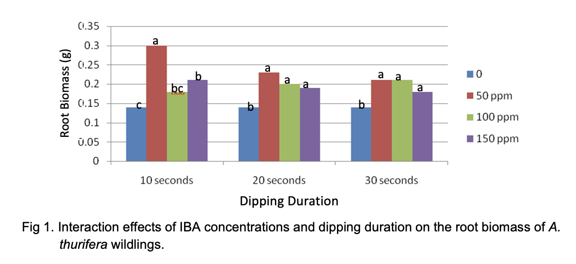
Figure 1. This is a random figure shown as example with caption [11 points]

Discussion [Heading 1][size 13]
The discussion part provides a opportunity for writers to state key results and how are these related to previous literature. In this section, it is important to restate the purpose and key findings of the research, present the interpretation of reults and compare these with previous studies. Highlight agreements, contradictions, and contributions. It also explains the implications of the research whether it is of theoretical significance or of practical relevance.

Conclusion [Heading 1][size 13]
The conclusion contains an overview of the study's results and findings, particularly to answer the objectives. The limitations or constraints in the sample, methods or scope should be reflected and how these affected the interpretation. This section also presents suggestions for future studies.

Acknowledgments [Heading 1]
This presents acknowledging contributions to the research article in the order that best represents the nature and importance of those contributions, such as intellectual assistance and funding support.

References [APA seventh edition] [Heading 1]
David, J., & Liss, R. (2006). Effective academic writing 3 (1st ed.). Oxford University Press.
Le, M. H. (2023). The application of critical thinking to short story analysis: An experiment on a new teaching process. International Journal of TESOL & Education, 3(2), 60–75. https://doi.org/10.54855/ijte.23325
Pham, V. P. H. (2021). The effects of lecturer’s model e-comments on graduate students’ peer e-comments and writing revision. Computer Assisted Language Learning, 34(3), 324–357. https://doi.org/10.1080/09588221.2019.1609521

Biodata
Write approx. 50 words, including your job position, institution, country, teaching experience, and research interests.

